Cross punisher part 2
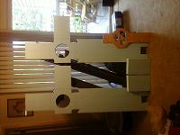

- One of my lovely friends has a husband with a garage filled with power tools that came in handy while cutting these out. I used a jig saw to cut out the crosses and a rotary saw and a scroll saw to cut out the wooden piece. Afterward there is still a lot of sanding to make the correct shape.

- The wooden piece is the trigger/handle. The two small cross arm pieces will be attached later.
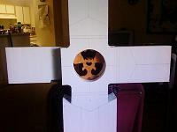
- The worse part of this project was carving out the space on the underside of the crosses for the trigger/handle. I used a dremel rotary tool. It is important to cut this space a depth of half the thickness of your trigger/handle. You do not want there to be a lot of wiggle room, you want a tight fit. Repeat this process on the second cross. Test the fit before you glue.

